Industrialization 4.0

Nokia & BSNL Joint collaboration

Contents
1 The future of Industry 3
2 Joint Collaboration 4
3 Business opportunities for Industry 4.0 5
4 Benefits 6
5 Proposed Solution Architecture 7
6 Network Requirements 8

The future of Industry
Technology is advancing. Machines are getting smarter. And consumers are becoming more demanding. As such, industry is facing several challenges, including increasing energy costs, the need to securely connect systems on a common infrastructure, increasing consumer demand for customized and personalized products and demand for products which are more complex to build and deliver. Many organizations are looking to closely couple their physical assets with the digital world – increasing automation and using data to create a more agile business.

Preparing the India for Industry 4.0

The Industry of the future will see people and machines working safely together to increase productivity and improve efficiency. As the fourth industrial revolution dawns, these organizations are already becoming more reliant on the use of cyber-physical systems – computer-controlled robots and machinery – to streamline and transform their processes. The use of analytics is also an essential tool, as organizations rely on the analysis of data to ensure accuracy, make informed decisions and even ensure safety for workers. These changes are being felt in all areas of industry, including, Manufacturing, Construction, Logistics, Power generation, and lastly Distribution and transportation.
And there are different ways in which these challenges faced by industry are addressed by LTE and future 5G technologies for the successful adoption of Industry 4.0.

Solution offers unique benefits in four key areas:-
- Flexibility
- Efficiency
- Low latency
- Data privacy
- Seamless mobility
- Excellent coverage

Industry level orchestration of use cases aid the running of applications at the correct location at the right time, based on technical and business requirements. Industrial robotics, automation video surveillance, asset tracking and other wide variability of Use Cases.
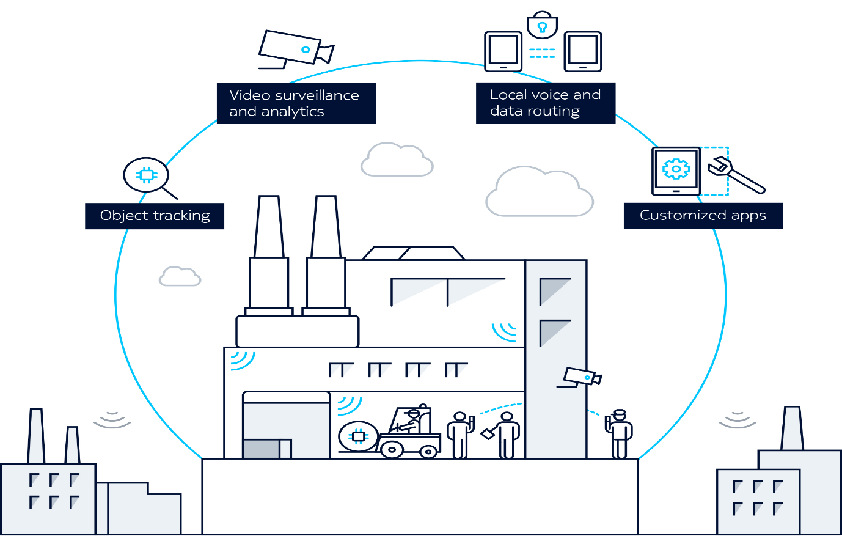

Depending on their own plans for growth and investment, different industries will adopt new technologies at varying paces. For those organizations that are expanding, it’s important to consider which technologies are being widely adopted. This can help them benefit from economies of scale. And it can also prevent them from being locked into proprietary systems which they could outgrow. Not only these futuristic technologies enable far greater flexibility than wired communications, it can also be scaled easily to meet business needs. And it is being developed to comply with all the appropriate safety and security regulations.

Joint Collaboration
Objective: The purpose of this document is to jointly Collaborate and demonstrate Industrialization 4.0 use cases in areas of Automation, Productivity/efficiency and Security .
The digitization of end-to-end business processes to create new value and stay ahead of competition has become a major trend in various industry sectors. Automation is a cornerstone of the digitization strategy of many enterprises, such as, manufacturing plants, refineries, warehouses, cargo terminals, public transportation hubs, and mines. Automation reduces manual labor input for products and processes. This is a positive development for efficiency, quality, safety, and for getting people back to doing what they are good at.
At the type of facilities mentioned above, a high performance wireless network is required to connect all moving assets, sensors and actuators, handheld devices, robots, machines, and vehicles. Enterprises have been considering LTE for this, but the services offered by mobile operators have mostly been targeted at connecting enterprise staff like subscribers when need of the hour is mobile operator driven private industrial network automation that provides dedicated network resources which can be tightly integrated with enterprise IT systems.
For such application LTE combines the benefits of licensed and unlicensed LTE technology with the deployment model of a private enterprise network, and offers the following benefits:
- High performance wireless connectivity with high uplink and downlink data rates and low latency, as is needed for bandwidth-hungry and highly interactive applications such as, professional augmented reality and virtual reality applications.
- Hundreds of simultaneous active connections per base station, paired with the highest spectral efficiency of common communication systems.
- Optimal reliability for critical communications due to uncontested spectrum, sophisticated quality of service mechanisms and interference management techniques, and carrier-grade system reliability.
- Seamless mobility based on the fast and robust LTE handover mechanisms, as is needed for reliably controlling driverless vehicles and drones on an enterprise campus.
- Multi-layer security with isolation from the public LTE network, SIM based authentication, ciphering and encryption of user data, and local data routing, as is needed for video surveillance and transfer of sensitive data records.
- Excellent coverage based on the long ranges that LTE base stations support, as is needed for large facilities, e.g. ports, plants, depots, terminals, etc.
- A wide variety of devices, including ruggedized terminals, tablets, laptops, and IoT modules.

Business opportunities for Industry 4.0
Business opportunities for Industry 4.0 / Private LTE
- Refineries (like HMEL refinery, HPCL Mumbai, IOCL paradip)
- Steel Plants (Bhillai, Rourkela, Bokaro)
- Mines (HZL Ajmer, NCL, ECL, Bellary mines, Jayant)
- Airports (Delhi, Mumbai, Bangalore, Chennai, Hyderabad)
- Heavy Industries (car manufacturing, Electronics manufacturing)
- Ports (hazira port, cochin ship yard)
- Social gatherings (Khumb mela, amarnath yatra)
- Big Sports events (IPL, ISL, HIL)

Benefits
BSNL
- Successful implementation will be first of its kind Asia pacific, Africa and Oceania region and this is going to generate immense positive feedback for BSNL & will be duly advertised, marketed by Nokia in India as well as Global reference in Trade shows, Trade Talks and multiple industry forums and Nokia will present BSNL as its partner in The Project.
- As part of implementation BSNL can over other instances post Nokia’s deployment can have potential additional revenue stream based on:-
    - Fixed monthly revenue based on number of SIM’s being utilized.
    - Fixed monthly rentals on Leased line provided to an Enterprise
    - Possibility to getting a deployment site within Enterprise premise with zero rental & zero security obligation.
- Post initial successful implementation – there are huge possibility of addressing diverse Industry level orchestration in sectors like mining, manufacturing, Oil & Gas, Space Research, Railways, Security forces, Manufacturing, Enterprise Public Safety in following domain;
  - Connectivity of Testers, Machines etc. In Manufacturing environment to centralized Manufacturing Server. (as replacement to traditional Ethernet cable and superiority of LTE over Wifi as wireless connectivity media for machines).
  - Tracking of Automatic Guided Vehicles (AGV) in Manufacturing floor.
  - Augmented reality (AR) applications for Operators guidance.
  - Mobile Edge Computing functionalities.
  - Push to talk applications for group of stakeholders in Manufacturing floor.
- Improve the BSNL brand value

Nokia
- Enables Business-to-Consumer (B2C) use-cases and Leverages localized content and environment context
- Improves coverage, security and quality of experience with Reduced backhaul and core network load and significantly improves latency

Proposed Solution Architecture
- The automation to Industry 4.0 is based on 3 main building blocks:
  - The local LTE network, including LTE base stations installed at an enterprise campus. Base stations can be macro/Small / Pico -cellular base stations, or a mix of both.
  - A compact server installed on an enterprise campus which hosts the Evolved Packet Core (EPC) functions that are required for locally connecting to enterprise systems. The server can also host enterprise edge applications that benefit from tight integration with the local LTE network, such as, device management and data analytics for IoT sensors, high accuracy asset tracking, and real-time video for remotely controlling driverless vehicles.

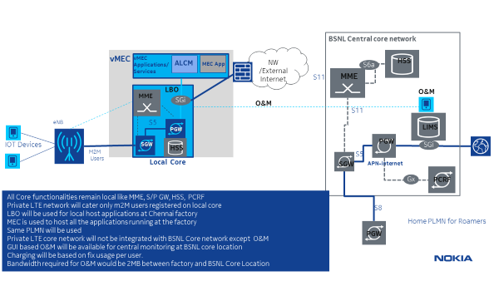
Figure 1: Industry 4.0 Enablement solution overview

Solution Details
- All Core functionalities remain local like MME, S/P GW, HSS, PCRF
- Industrialization 4.0 LTE network will cater only M2M private users registered on local core
- LBO (local breakout) will be used for local host applications at Enterprise / industry location
- Local servers is used to host all the applications running at the Enterprise / industry location
- Same PLMN will be used
- Industrialization 4.0 LTE core network will not be integrated with BSNL Core network except O&M
- GUI based O&M will be available for central monitoring at BSNL core location
- Charging will be based on fix usage per user.
- Bandwidth required for O&M would be 2MB between Enterprise / industry location and BSNL Core Location

Network Requirements

BSNL | Nokia | Enterprise
SIM cards – As per Enterprise requirement | Mirco Core network | Industry machines with LTE controller
Availability of 4G Radio Infrastructure and spectrum |  | Application platform
2Mb Backhaul connectivity between enterprise premises & BSNL Core for O&M
RF planning to be done to avoid interference with existing BSNL 3G / 4G LTE network till additional 5Mhz is available in 2100 MHZ band.

